**Use case 6: Sponsor wants to donate**

**Primary Actor:** Sponsor

**Scope:** Hamtastic

**Stakeholders and Interest:**

User - Sponsor

Server-

**Precondition(s):** The user must successfully log in to the site.

**Minimal Guarantee(s):** User uses the payment service API to donate money.

**Success Guarantee(s):** User receives a confirmation in the form of a thank you message.

**Trigger:** User selects option to donate.

**Main Success Scenario:**

1. The user goes to the top sponsor list page.
2. The user selects the donation link.
3. The user is taken to a page where they can add their payment information.
4. The user fills in the form generated by the payment service API.
5. The user types in the amount of money they would like to donate.
6. The user confirms and submits the payment amount.
7. The payment API processes the request.
8. The database updates payment amount and compares the amount with the other top sponsors list.
9. The user is presented with a thank you message from Hamtastic.

**Extension(s):**

1. The user enters an invalid value for a field in the form generated by the payment service API.
2. The server encounters a processing error

**Use case 6: User wants to view top sponsors.**

**Primary Actor:** Any user

**Scope:** Hamtastic

**Stakeholders and Interest:**

User - Any user

Server-

**Precondition(s):** The user must successfully log in to the site.

**Minimal Guarantee(s):** User can click on the page with the top sponsors.

**Success Guarantee(s):** User can view top sponsors list.

**Trigger:** User selects the top sponsors list page.

**Main Success Scenario:**

1. The user selects the link that takes them to the top sponsors page.
2. The user is able to view the list of sponsors who have donated.

**Extension(s):**

1. The server encounters a processing error.

**Sequence Diagrams**

**Sponsor wants to donate**

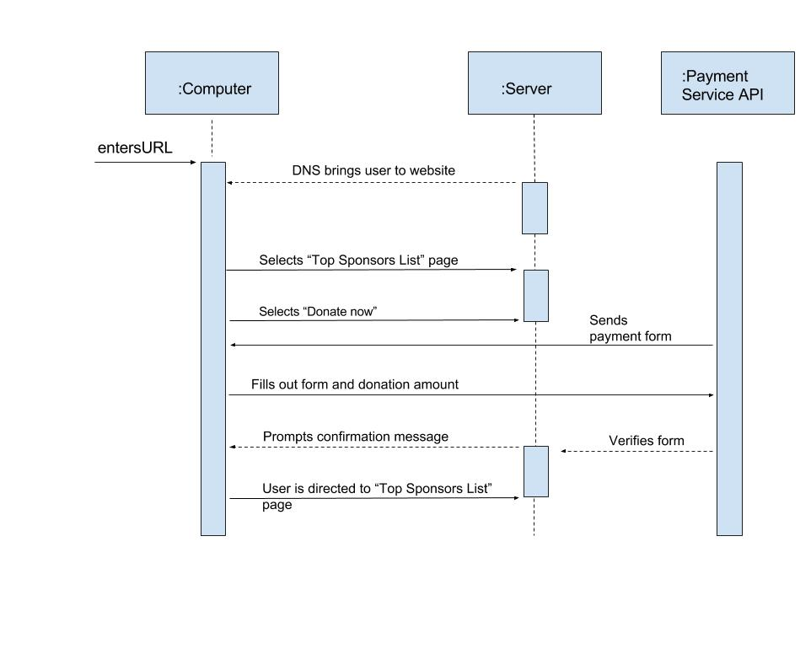

**User wants to view top sponsors**

